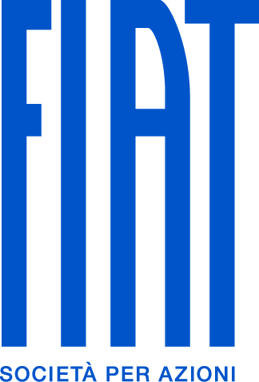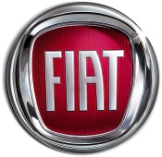

Auto Maintenance Services is
FGAI Aftersales Dealer of the Year

Highlights:
- Auto Maintenance Services Ltd. has been named as 2011 "Aftersales Dealer of the Year"
- First win for Finglas-based FIAT, Alfa Romeo and FIAT Professional aftersales specialist
- Auto Maintenance Services overcame intense competition from entire FGAI network
- Nine-strong staff is fully qualified and trained by FGAI to the highest standards.

Press Release:
Auto Maintenance Services Ltd. has been named as FIAT Group Automobiles’ Ireland “Aftersales Dealer of the Year” following its impressive performance in 2011. Auto Maintenance Services Ltd. is an authorised service and repair specialist for FIAT, Alfa Romeo and FIAT Professional vehicles, and is based in the NorthPark Industrial Estate in Finglas, Dublin 11.

The company was established in 1998 and currently employs a staff of nine and of its technicians are all fully-qualified and trained to FGAI’s exacting standards. In addition to providing authorised maintenance, repair and warranty services, Auto Maintenance Services Ltd. also offers full tyre an wheel-balancing service, bodywork repair and in-house transmission repair facilities, as well as low-cost vehicle rental and a collect-and-return service.

Upon receiving the award, Managing Director Lee Dunne said, “I am delighted to receive this award as it confirms the hard work and commitment of everyone in Auto Maintenance Services to be the very best in the business.”

Presenting the award to Mr. Dunne, Managing Director of Fiat Group Automobiles Ireland Adrian Walsh said, “Winning this award is no small achievement. Each FGAI service agent must adhere to the high standards of technical knowledge and customer satisfaction so to be the best amongst such highly-rated competition is a credit to Auto Maintenance Services and its staff.”

- Ends -

Photo Caption:
Pictured L-R is Adrian C. Walsh, Managing Director of FIAT Group Automobiles Ireland; Lee Dunne Managing Director of Auto Maintenance Services Ltd and Joe Somers, Aftersales Manager for Fiat Group Automobiles Ireland.

